MS SQL SERVER
Standard Operating Procedures
(SOP)
SQL Server 2014 Patching

Submitted to



BY



CIS, Wipro Limited

Document Details
Project Name | Innogy SE
Account | CIS
IT Component/Application Title | SQL Server 2012 Patching
Current Version | 1.0
List of Contributors | Ayushi Srivastava
Customer Contact Information

Version History
(All revisions made to this document must be listed in chronological order. All revisions must be approved. Review and Approval can be done by an internal source or by the customer)
Version | Date of Revision | Description | Author | Reviewed By | Approved By
1.0 | 22-02-2019 | Complete Document | Ayushi Srivastava | Pradipkumar Kansara | Santosh Badiger
Document Distribution List
S.No | Name and Company | Purpose
1 | RWEIT-SQLDBA | Document is useful for maintaining SQL agent security.
2

TABLE OF CONTENT

1. Purpose 1
2. Scope 1
3. SQL Server Patching 1
4. Links to get updated patch 1
5. Pre-Requisites 2
6. Before Installing Service Pack 2
7. Steps to install SP 3
8. Reference 11

Purpose
This document is prepared for Implementing SQL Server Patching to avoid vulnerabilities and upgrade SQL Server with new features which are released with every new Service Pack, either it is a CU or a GDR, in SQL Server.

Scope
This document is prepared for GSMC Wipro sustenance team and provides the concepts of Upgrading SQL Server Security Patch for the administration of the SQL Server database at Innogy.

SQL Server Patching
SQL Server Cumulative Patch Upgrade: A hotfix fixes a single issue, and hasn't been extensively tested. A cumulative update is a rollup of several hotfixes, and has been tested as a group. A service pack is a rollup of several cumulative updates, and in theory, has been tested even more than cumulative updates.
GDR: A General Distribution Release (GDR) is simply a kind of hotfix, or patch that contains specific fixes, and is intended for installation on all SQL instances. Cumulative updates: A cumulative update (CU) is an update that contains all previous hotfixes to date.
Service Pack: Once it reached a stable version, Microsoft released the RTM (Release to Manufacturing) version. Service Packs are used to establish new service baselines for SQL Server. For each new baseline, Microsoft provides Cumulative Updates for around 12 months before the next Service Pack release.

Links to get updated patch
From below link, we can track the latest patch updated from Microsoft that can be applied to SQL Server 2014
https://sqlserverbuilds.blogspot.com

Pre-requisites
- Find missing .msi and .msp files.
- Click on FixMissingMSI_V2.2ForNET45 → FixMissingMSI (application)
- Fix the missing files.

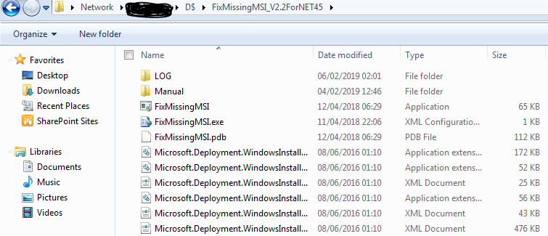

Before Installing Service Pack
Please follow below steps before upgrading SQL Server 2014.
1. First install Service pack on UAT/Test environment and test your application thoroughly. Make sure you test all your application functionalities completely. Although service packs or thoroughly tested Microsoft recommends to test it in your UAT environment before proceeding with deployment in production environment.
2. Backup system and user databases. Use TSQL backup command or SQL Server Management studio GUI to backup system and user databases. Since you backup system and user databases you don't need to backup jobs, SSIS packages, mail profiles, linked servers and logins as all of these would be included in MSDB and Master database backups.
3. Make sure enough space is available on drive where resource/system databases are present. Resource database is utilized during service pack upgrade. The Resource database makes upgrading to a new version of SQL Server an easier and faster procedure. In earlier versions of SQL Server, upgrading required dropping and creating system objects. Because the Resource database file contains all system objects, an upgrade is now accomplished simply by copying the single Resource database file to the local server.
4. Service pack upgrade would require a downtime of application. Make sure application does not access database during service pack upgrade. Make sure you stop all jobs and activities on database before proceeding. You don't need to shutdown database services to apply service pack.
5. Make sure you are administrator on the system and always run the service pack executable with administrator privileges.
7. Steps to Install SP
- Click on download mark on the link and download 64 bit or 32 bit of installable as per your machine architecture. We would be upgrading SQL Server 2014 64 bit to SP2 so download will be SQLServer2014SP2- KB3171021-x64-ENU.exe. Download the installable on local drive
- From command prompt, go to the folder/directory where the Service Pack set up (SQLServer2014SP2- KB3171021-x64-ENU.exe) is placed and run below command. it will start extracting and will show as per below screenshot.
For Example:
D:\SP2>SQLServer2014SP2-KB3171021-x64-ENU /extract: "D:\SP2"

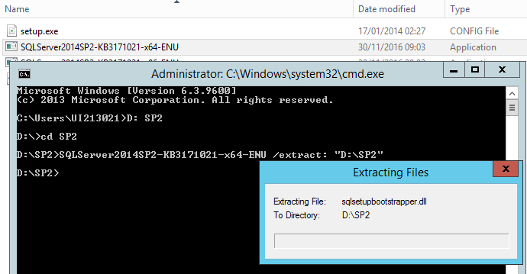

- Click the setup file → Run as Administrator
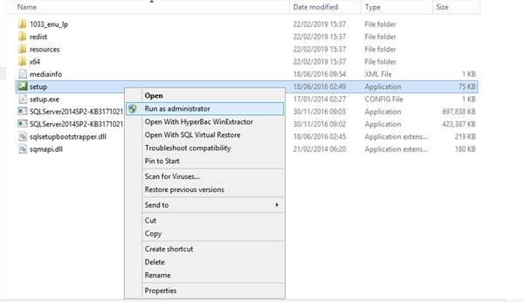
- After extraction is complete below message will appear. extraction might take few minutes.
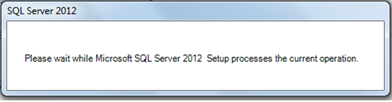

After finishing below screen will appear. You can click on show details you check what all checks are performed by SQL server before starting installation of SP2. Sometimes is OS on which SQL Server is installed has restart pending it will show here as error saying restart pending. In that case you have to cancel the setup restart the OS and then again run the setup as administrator
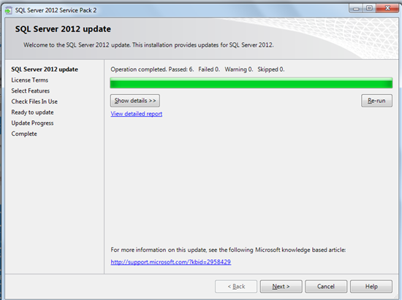\

6. After you click next you would reach to License term page. You need to select I accept check box and click on next.
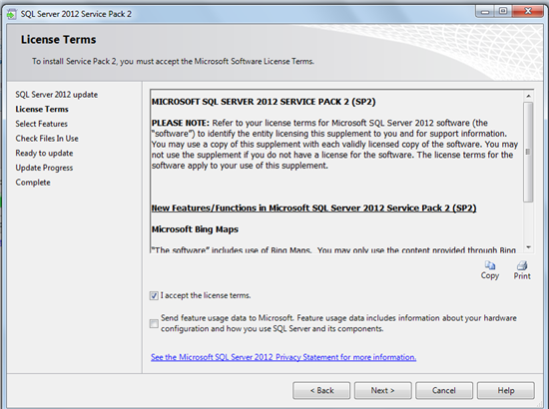

After that Select Features page will appear on which you can select features of SQL Server you want to upgrade to SP2 and click next.
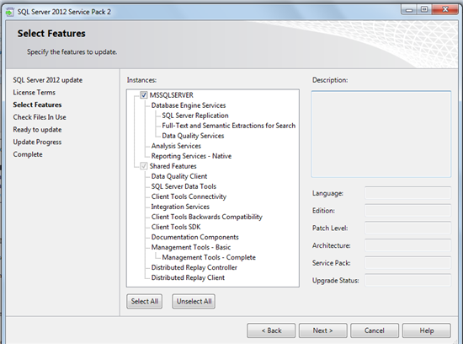

Next we would move to page Check Files in use. On this page SQL Server check files related to SQL Server which are currently used by user and upgrade to such features will only be visible after SQL Server restart.
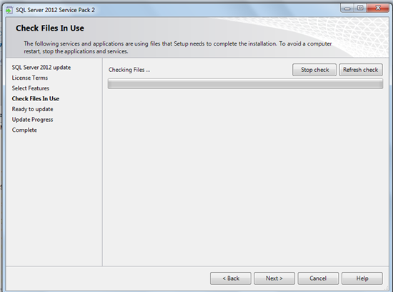

After checking files if SQL Server service pack installation found some already used components of SQL Server it will point out as below. If you see SQL Server management studio is open with one other file.

You can click on next and proceed but in that case you will have to RESTART SQL Server service after installation of service pack completes. Or else you can close the applications and click on refresh check if you do not want to restart SQL Server service.
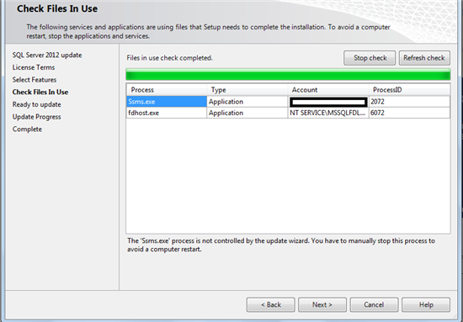
9. After you are done with the choice click next.

This will take you to ready to upgrade screen where you can cross check what are features being updated.
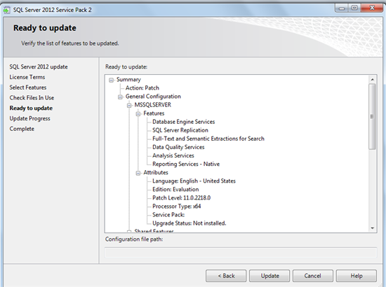

Click on update to install SP2. This will take you to install progress screen.
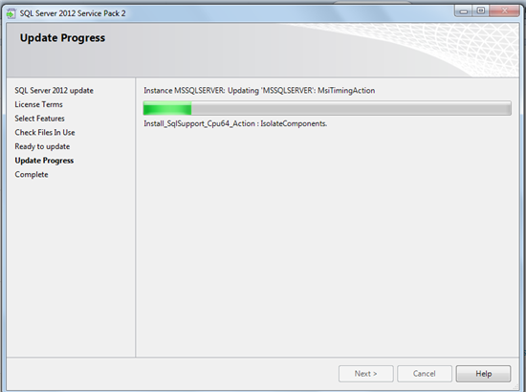

Allow installation to complete and if it completes successfully you would get below screen.
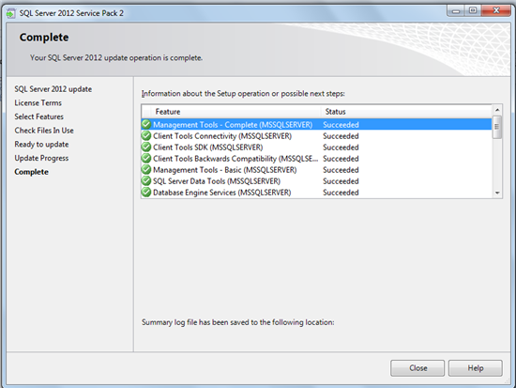
If Service Pack install fails please take help of Log files present at location C:\Program Files\Microsoft SQL Server\110\Setup Bootstrap\Log assuming C drive us system drive.

Reference:
https://social.technet.microsoft.com/wiki/contents/articles/25632.how-to-install-sql-server-2012-sp2-on-standalone-sql-server-instance.aspx

